**June 2019 DVMP meeting – MIT Group Update**

**Progress since last meeting**

* Oriented ourselves as new members of CLAS12
* Explored CLAS12 data taking structure, storage system, and analysis options
* Have been able to carry out basic analysis and generate elementary plots

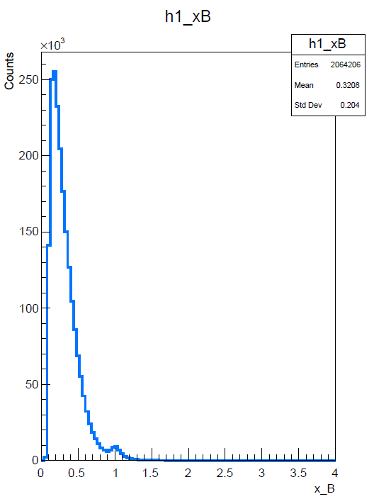

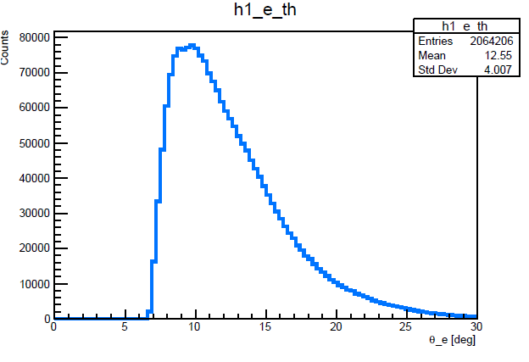

Data from /work/clas12/rg-a/trains/v2/skim8_ep/skim8_5038.hipo

**June 2019 DVMP meeting – MIT Group Update**

**Path Forward**

* Suggested analysis tools – CLAS12Tool ?
* Suggestions for analysis work
  + results to reproduce
  + areas to investigate
* Other comments on path forward

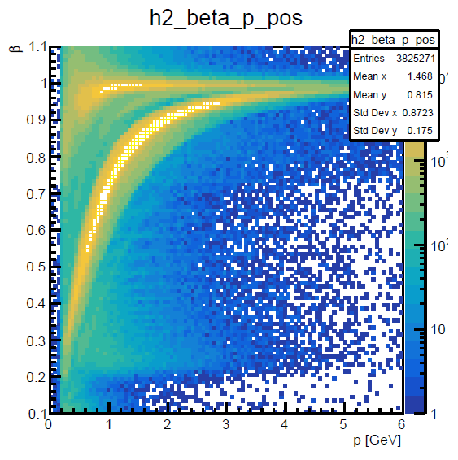

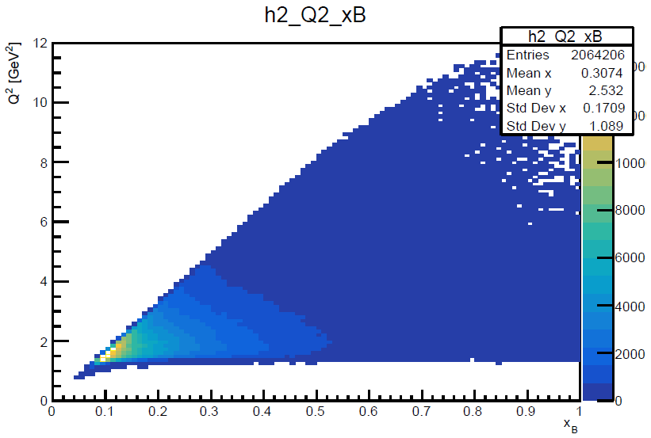

Data from /work/clas12/rg-a/trains/v2/skim8_ep/skim8_5038.hipo